2023 Create Your Own Mount Rushmore of European History- (Honors)
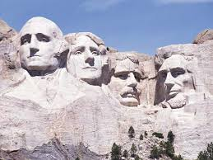
Mount Rushmore is a national monument located in Black Hills of South Dakota. It features 60 foot sculptures of the heads of four former Presidents of the United States: George Washington, Thomas Jefferson, Theodore Roosevelt, and Abraham Lincoln. The presidents were selected on the basis of what each symbolized. Washington represents the struggle for independence, Jefferson the idea of government by the people. Abraham Lincoln was included because of his views on equality and the permanent union of the states, and Theodore Roosevelt for role of the United States on the world stage. Over the course of this year, we have studied many famous and infamous historical figures. Your assignment is to create your very own Mount Rushmore of European history. Select four individuals that you feel have made the greatest impact on the history of Europe (which of course, in turn affected the history of the United States).
Using the website Face in Hole , upload pictures of the four people you selected on Mount Rushmore. Along with the picture of Mount Rushmore, you need to write a paragraph detailing the reasons why that person deserves a spot on the Mount Rushmore of European History. Your reasons must be historically accurate. You need to cite your pictures on Noodletools and share it with Mrs. Matjasic. Save the picture and the explanations to a word document and upload it to Schoology by the end of class on our last day in the library.
Rubric: Mount Rushmore of European History
Picture of Mount Rushmore of European History /10
Person #1-paragraph explanation /10
Person #2- paragraph explanation /10
Person #3- paragraph explanation /10
Person #4- paragraph explanation /10
Total /50
The works cited is worth 20 points (5 for each picture). See the Research Pathfinder for the rubric.

